Mahindra Powerol HUPS business chosen as Power Brand 2011-12

Mahindra Powerol HUPS has been chosen by the Indian consumers as one of the “Power Brands 2011-2012”. This is the second successive year Powerol has been awarded with Power Brands. This year the award is for Mahindra Powerol HUPS for the ‘Intelli Series’, which is most intelligent & innovative inverter available today. The award was won under “Electrical Components & Power Products category”.
The Power Brand 2011-12 has been given to the top 100 brands in India. The marketing initiatives of these brands are also been taken into consideration along with legacy, recall, and impact. Mahindra Powerol brand has ‘made a cut’ and is a challenger to the market leaders and is ready to establish the impact in the market. Brand recall and marketing initiatives undertaken by Powerol have propelled them into the league of Power Brands today.

Power Brands is an initiative undertaken by Planmann Media, it is a consumer driven research activity of India’s most powerful brands, the research conducted by ICMR (Indian Council of Market Research).

The survey was conducted on a one-on-one basis with the consumer to gauge the consumer’s connect with each brand and to receive accurate feedback on each brand. It was the first brand study ever in India, to encompass different parameters to establish a brand's credibility. Parameters which are extremely essential for the survival, revival, growth and revolution of a brand were taken in to consideration for the survey.

The awards were given away in a glittering ceremony at The Kingdom of Dreams, Gurgaon, on 25th June, 2012 amidst august gathering of the top officials of marketing & advertising fraternity.

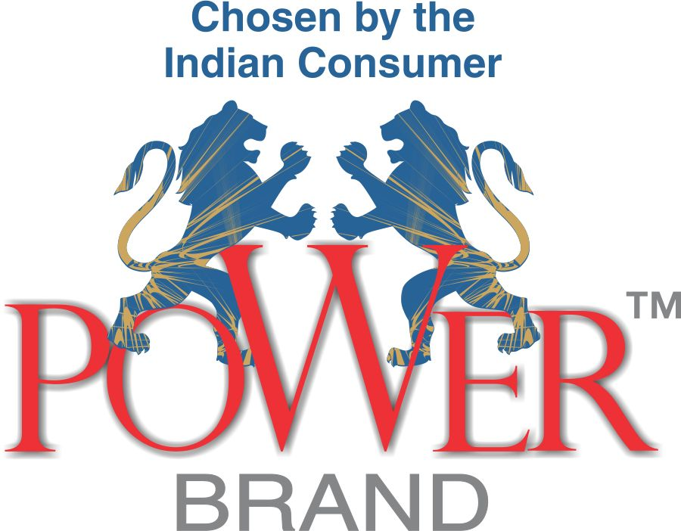

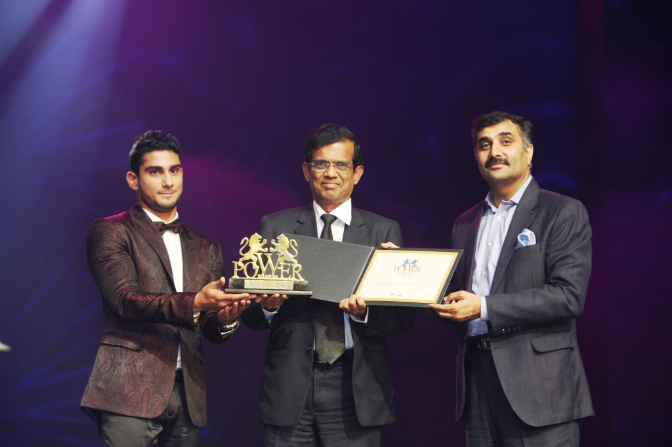

Mr. P Palaniappan, Sr. VP , Powerol receiving the Power Brand award from the hands of Mr.Prateik Babbar, Film Actor & Mr. Ashwani Arora, Jt. MD, DAAWAT

