MAHINDRA POWEROL’S FACEBOOK PAGE “SEE THE LIGHT” CROSSED 1LAC FANS

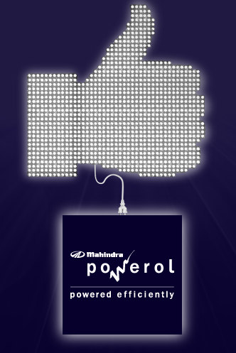
The facebook fan page of Mahindra Powerol “See the Light” has crossed 1Lacs fans. The page started around a year back is today powered by 100000 fans.

The fan page is called ‘See the Light!’ positioned as the brightest community on Facebook. Mahindra Powerol has taken a positive approach and look forward to adding light to the world. Through this page Powerol is promoting the brand Mahindra Powerol for products DG Sets & HUPS.
With this initiative Powerol has gained remarkably in terms of online visibility.

Do continue with your support and those who have not joined please join today; http://www.facebook.com/MahindraPowerol

