Mahindra Powerol chosen as Power Brand 2010-11

Mahindra Powerol has been chosen by the Indian consumers as one of the “Power Brands 2010-2011”. Power Brands is an initiative undertaken by Planmann Media, it is a consumer driven research activity of India’s most powerful brands, the research conducted by ICMR (Indian Council of Market Research). The results were announced after conducting extensive surveys on a pan India level over a research base of 20 centres and 5000 respondents.

The survey was conducted on a one-on-one basis with the consumer to gauge the consumer’s connect with each brand and to receive accurate feedback on each brand. It was the first brand study ever in India, to encompass different parameters to establish a brand's credibility. Parameters which are extremely essential for the survival, revival, growth and revolution of a brand were taken in to consideration for the survey.

The awards were given away in a glittering ceremony at The Hotel Intercontinental EROS, New Delhi, on 4th February, 2011 amidst august gathering of the top officials of marketing & advertising fraternity.

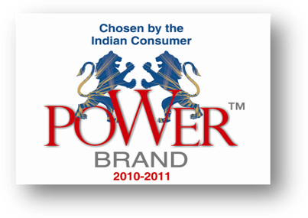

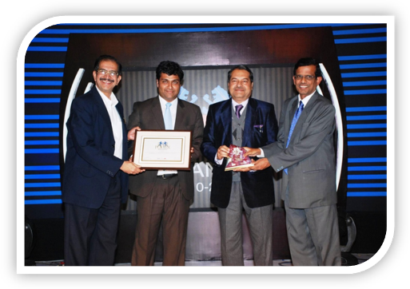
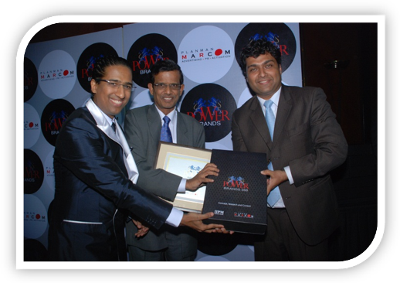
Mr. P Palaniappan, Sr. VP , Powerol and Mr. Joy Ghosh, Brand Manager receiving the Power Brand award from the hands of Mr. Bhaskar Chatterjee, Secretary to Govt. of India, Ministry of Heavy Industries & Public Enterprises & Mr. T Sudhakar Pai, MD, Kurl-on Group.

Mr. P Palaniappan, Sr. VP, Powerol & Mr. Joy Ghosh, Brand Manager, Powerol receiving awards from Mr. Arindam Chaudhuri of Planmann Media.

